**Challenging: ALL YOUTH**

**Faith Formation classes, Elementary School Students, High School Students, Scout troops, Junior/Senior Youth Groups**

[](http://www.google.com/imgres?imgurl=http://cdn2.irishviews.com/irishviews-cdn/pennies4.jpg&imgrefurl=http://imgkid.com/pennies-clipart.shtml&h=768&w=1154&tbnid=XMXOtywVmwEkZM:&zoom=1&docid=BKP_PSv1Z7C22M&ei=80C0VJLyJpPiggS004KIDg&tbm=isch&ved=0CFsQMyg0MDQ&iact=rc&uact=3&dur=1010&page=3&start=42&ndsp=18)**Things you can do:**

**Say a simple Hail Mary or Our Father before bed or before a meal, for your Pastor, or favorite Priest, Sister, Deacon, etc, and put a penny in the Priest bottle, or a container at Home *for each prayer*.**

**Begin a Class, or Meeting with a Prayer for Vocations and ask the others in the group to donate a Penny for our Priests, Deacons, Seminarian, Brothers and Sisters for their support. (A ‘Penny A Prayer’)**

**Find a Penny, say a prayer and save it.**

**Adopt a Seminarian and send cards, write letters, etc to a special seminarian. Visit the Diocesan website: St Petersburg Vocations:** [**www.spvocation.org**](http://www.spvocation.org)

**Arts & crafts project: Make a “Priest or Sister Bottle” to put your pennies into.**

**Involve your Pastor. One parish in the Diocese has a locked box in the back of the church for everyone’s pennies – don’t forget the prayers.**

**Use the money to take your favorite Priest, Sister, etc for Ice Cream or donate directly to St Petersburg DCCW, Inc.**

**Did you know that the Diocese of St Petersburg has 25 young men studying for the Priesthood?**

**"Love one another as I have loved you". Jn13:34**

*‘Lord, when did we see you hungry or thirsty or a stranger or naked or ill or in prison, and not minister to your needs?’* *He will answer them, ‘Amen, I say to you, what you did not do for one of these least ones, you did not do for me.’* Matthew 25:44-45



Florida currently has the 6th largest homeless population in the United States. (2013 statistics)

There are many families with children living on the streets in our Dioceses. ‘Hugs for the Homeless’ is an annual project started by the Florida Council of Catholic Women, three (3) years ago, to help the homeless in our State. The Council of Catholic Women in Diocese of St. Petersburg has been a great contributor since the inception of this project. The idea was to offer chocolate “HUGS” for a donation of any kind. This works, but we can use the word ‘Hugs’ in another manner. A Hug is an affectionate greeting, it indicates care of the individual.

How can you help with this project? Have a candy sale and ask friends to help. Another play on this would be, if you hug someone or get a hug, put a coin in a jar and save. Most homeless people do not get hugs. Share this idea and see how it will blossom.

The donations of money has helped countless individuals and families recover from their hardships.

**Visit:** [**www.pinellashope.org**](http://www.pinellashope.org) **to see the great work of Mercy being done in our Diocese.**

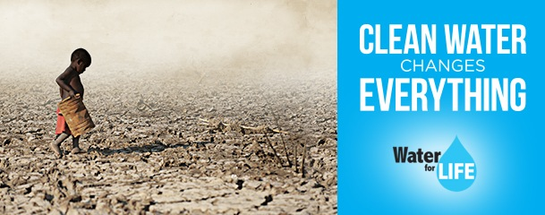

**Water For Life** The average cost to drill a new well this year will remain at $4800. With wells capable of serving 1000 villagers, that means for as little as $4.80, a child can have water for life.

1. [](http://www.google.com/url?sa=i&rct=j&q=&esrc=s&source=images&cd=&cad=rja&uact=8&ved=0CAcQjRw&url=http://www.shutterstock.com/s/stack+of+dimes/search.html&ei=iJi1VIakNIuXNuOmgMgH&bvm=bv.83640239,d.eXY&psig=AFQjCNGdBU-wGkxEKmbvpNGOshz_j12imA&ust=1421273563438044)

CRS has long held a close and fruitful relationship with the National Council of Catholic Women (NCCW), which since 1946 has helped CRS raise $12 million for programs that help women and families.

Founded in 1943 by the [United States Council of Catholic Bishops](http://en.wikipedia.org/w/index.php?title=United_States_Council_of_Catholic_Bishops&action=edit&redlink=1), the agency provides assistance to 130 million people in more than 90 countries and territories around the world.

Nothing is as essential to survival as water, and although nearly a billion people lack access to it, [we are helping CRS bring clean water to those in need each day](http://crs.org/united-states/every-day-is-world-water-day/).

CRS and NCCW help communities to find, tap and manage water sources. Through inexpensive technologies such as boreholes, community reservoirs and cisterns,Water for Life projects help communities reduce disease, increase farming efficiency and improve sanitation and health conditions.

92% of the donations to CRS goes directly to the programs, while only 8% goes to fundraising, awareness and administration.

**Proverbs 25:25 *“Like cold water to a weary soul, so is good news from a distant land.”***

**A Small Amount**

**Goes a Long Way**

**“Penny A Prayer”**

**for vocation awareness**

**Hugs for the Homeless**

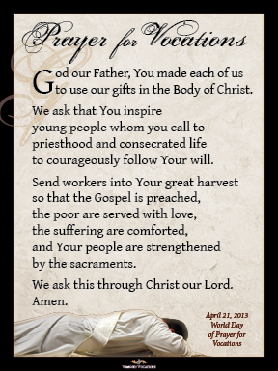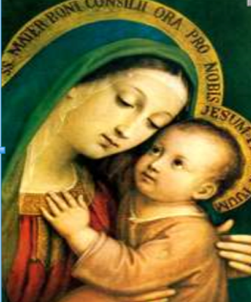

Calling All Youth

To The Challenge

St Petersburg Diocesan Council of

Catholic Women

**Celebrating 47 Years**

Patricia A Hanson, President

[rh5405@yahoo.com](mailto:rh5405@yahoo.com)

813 731 1629

[**www.spdccw.org**](http://www.spdccw.org)

**TO: Parents, Teachers, Catechists, Leaders and Diocesan Youth**

*The Diocesan Council of Catholic Women is beginning a Program to expand three of our on-going Works of Charity (Catholic Social Justice Issues) to help educate the youth in our Diocese and to ask them to become more involved in these 3 highlighted Projects.*

If you are interested in donating to any of these 3 worthy causes, please feel free to send a tax-deductible donation to: **St Petersburg DCCW, Inc** and put in (parentheses) the Charity you are donating to: ***Penny A Prayer*,** which benefits the Seminarians in formation from the Diocese of St Petersburg; or ***Hugs for the Homeless,*** which will be used to help countless people and families in shelters return to homes, jobs and security; or ***Water For Life***, which will help build wells in some of the poorest areas in our World.

Please visit our website at [**www.spdccw.org**](http://www.spdccw.org) for more information on these and other projects sponsored by the St Petersburg Diocesan Council of Catholic Women, Inc.

Checks can be sent monthly: Money collected will be dispersed by the DCCW Treasurer appropriately.

If do not wish to support these projects financially, please remember to pray for the success of these projects and especially pray for our Diocesan Seminarians. Thank you.

*‘Amen, I say to you, whatever you did for one of these least brothers of Mine, you did for Me.’ Matthew 25: 40*

**The St Petersburg Diocesan**

# **Council of Catholic Women**

# **Invites You To Participate**

# **In Three Catholic Social Justice Issues**

# In Our Area

# 

We are

The Voice

Of

Catholic Women