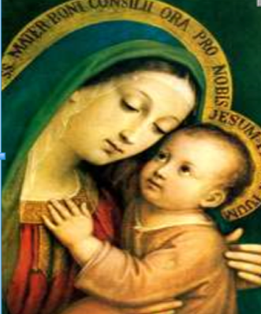
Our Lady of Good Counsel
We are
the Voice
of Catholic Women
St Petersburg Diocesan Council of
Catholic Women
Mary M Woltman, President
woltmanmom.catholicvoice@gmail.com
813 766 7788
WWW.spdccw.org
St. Petersburg Diocesan Council of Catholic Women
Individual Membership Application
Are You A
Person
WHO CARES?

Join the Women of the
St Petersburg Diocesan
Council of Catholic Women and make a
Difference TODAY !
Name:_____________________________________________
Address:___________________________________________
City:____________________________ Zip________________
Phone:___________________ Cell ______________________
Email______________________________________________
Parish_____________________________________________
Parish Address ______________________________________
$10 Check Payable to St Petersburg DCCW, Inc
Please Mail check to:
IF NOT US, WHO?
IF NOT HERE, WHERE?
IF NOT NOW, WHEN?
IF NOT FOR THE KINGDOM, WHY?
Patricia Hanson
1215 East Powhatan Avenue
Tampa, FL 33604
813 731 1629

DCCW By-Laws: Article IV Membership: In the event
there is no organized parish women’s group
Affiliated with Council, single membership shall be
available on application to either the District President
or the Diocesan President. A single member shall be eligible
to hold office and have voice. *
*For additional Individual Membership benefits please
contact Mary Woltman, St Petersburg DCCW President.
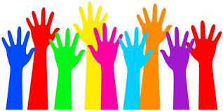

National Council of Catholic Women
Mission Statement
"The National Council of Catholic Women acts through its affiliated organization to support, empower and educate all Catholic Women in spirituality, leadership and service. NCCW programs respond with Gospel values to the needs of the Church and society in the modern world".
“To live charitably means not looking out for our own interests, but carrying the burdens of the weakest and poorest among us.” Pope Francis
National Council of Catholic Women*
(NCCW)
Florida Council of Catholic Women
(FCCW)
St Petersburg
Diocesan Council of Catholic Women
(SPDCCW)
spdccw.catholicweb.com
St Petersburg DCCW Districts
Our Lady of Grace, W Hillsborough County
Our Lady of Life, Hillsborough/ E Pasco County
Our Lady of the Mystical Rose, Hernando/W Pasco County
Our Lady of the Skies, E Hillsborough County
Our Lady of the Snows, Citrus County
Our Lady, Star of the Sea, S Pinellas County
Our Lady of the Way, N Pinellas County
Councils/Guilds/Affiliates

*NCCW is a member of the World Union of Catholic
Women’s Organizations (WUCWO)
The St Petersburg Diocesan
Council of Catholic Women Support:
US Conference of Catholic Bishops
Spiritual and Legislative Issues
Catholic Days at the Capitol
Speak for Religious Liberty
Speak on behalf of those in need
Religious Vocations Awareness
Bishop's Vocation Fund
Penny A Prayer for Priests/Vocation /Awareness
Catholic Social and Moral Teachings
Life Long Faith Formation Programs
Ecumenical and Interreligious Programs
Marriage, Families, Pregnancy Support
Youth Ministries
Migrant Workers Rights
Literacy Programs
Works of Peace and Reconciliation
Heifer International
Apostleship of the Sea Ministry
Voter Registration
Defend Against:
Domestic Violence
Homelessness
Human Trafficking
Under-Age Domestic Sex Trafficking Social Injustice

We Support: National Council of
Catholic Women Programs:
Water for Life
Madonna Plan
Help a Child
Refugee Program
Fair Trade
Our Diocesan women volunteers reported more than
1,570,000 Service Hours (2012-2014)

“Not all of us can do great things. But we can do small things with great love.”

Blessed
Mother
Teresa of
Calcutta

